LBS2ITS Newsletter No. 4
LBS2ITS - Project outcome presentations
June 18, 2022

Presentation at the ISPRS Congress in Nice, France
Guenther Retscher successfully presented an outcome of the LBS2ITS project at the XXIV Congress of the International Society of Photogrammetry and Remote Sensing in Nice, France, from June 6 to 11, 2022. His presentation on June 7 entitled ‘New Opportunities with PBeL (Problem Based e-Learning) for the Erasmus + Capacity Building in Higher Education Project LBS2ITS’ provided an insight into the integration of PBL (Problem Based Learning) with e-Learning which was developed in the course of LBS2ITS.
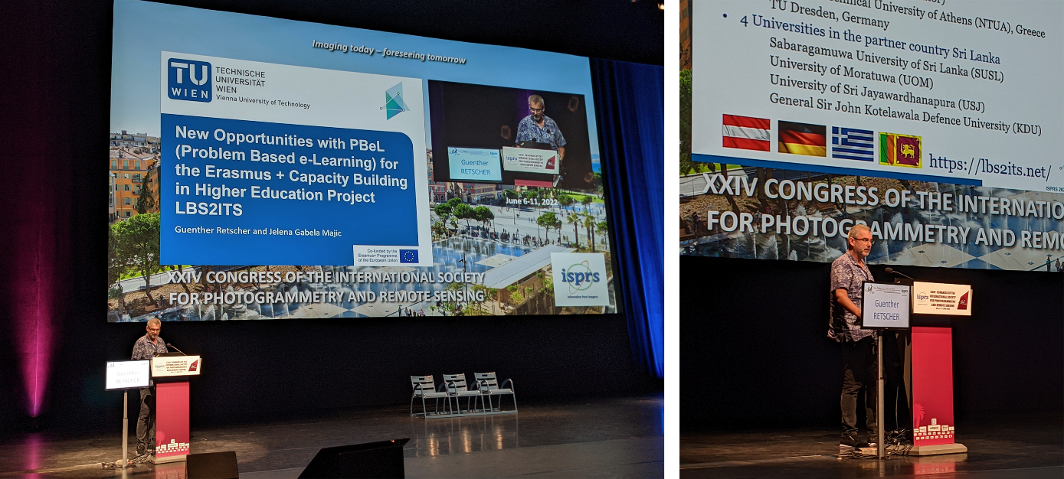
Prof. Günther Retscher at the ISPRS Congress
In the courses modernization carried out in LBS2ITS, special attention is paid to the development and/or update of the courses to be implemented with these two pedagogic forms. Thus, teaching with an emphasis on learning outcomes is a central theme building a fully immersive and integrated LBS teaching and learning experience with the LBS application of ITS in mind. As e-learning and PBL must be combined and integrated nowadays, the new term PBeL was proposed to demonstrate these developments. The approach and background information on the theory and the LBS2ITS project were presented at the congress.

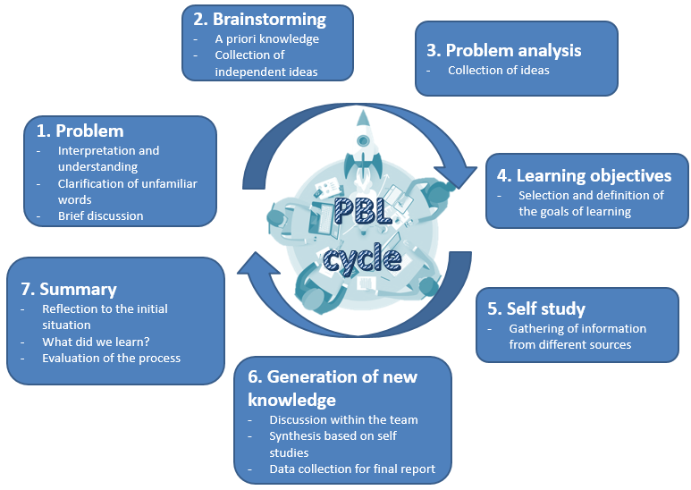
The PBeL (Problem Based e-Learning) cycle
Presentation at the 8th International Conference on Higher Education Advances – HEAd’22, June 14-17, 2022, Valencia, Spain
The HEAd’22 conference was held in Valencia, Spain in June 2022 for the 8th time. It is a platform for researchers and practitioners to exchange ideas, experiences and research results relating to the preparation of students and the organization of higher education systems. More than 100 papers have been selected for presentation. The respective publication can be found at: http://ocs.editorial.upv.es/index.php/HEAD/HEAd22/paper/view/14473
Topics of presentations included themes such as
- Innovative materials and new tools for teaching
- Teaching and learning experiences
- Educational technology (e.g., virtual labs, e-learning)
- Evaluation and assessment of student learning
- Emerging technologies in learning (e.g., MOOC, OER, gamification)
- Scientific and research education
- Experiences outside the classroom (e.g., practicums, mobility)
- New teaching/learning theories and models
- Globalization in education and education reforms
- Education economics
- Entrepreneurship and learning for employment
- Education accreditation, quality, and assessment
- Competency-based learning and skill assessment
from participants from all over the world.
Georg Gartner from TU Wien presented the paper “From project-based to problem-based learning in engineering disciplines: enhancing cartography and geomatics education”, collaboratively written by Georg Gartner, Andrea Binn, Jelena Gabela, Günther Retscher, Vassilis Gikas, Manuela Schmidt and Wangshu Wang, where the experiences of our LBS2ITS project have been shared. The presentation was well received and several follow-up contacts have been built. Based on the questions and feedback the lessons learned will be used to enhance parts of our project work.

Günther Retscher and Georg Gartner

