LBS2ITS Newsletter No. 3
Train-the-Teachers Workshop “Transportation system planning for smart and liveable cities”
April 4, 2022

The first train-the-teachers workshop “Transportation system planning for smart and liveable cities” in the LBS2ITS project, took place from 28 March to 1 April 2022 at the University of Moratuwa (UOM) in Sri Lanka. The workshop was organized jointly by the LBS2ITS team from TU Dresden, who was, amongst others, responsible for the concept, providing material, and lecturing. The local organizing committee from KDU and UOM provided a great venue for the workshop at the green UOM campus with the best working conditions despite the economic crisis in the country and various related difficulties.
Around 20 participants from all Sri Lankan partner universities in LBS2ITS took part and formed an interdisciplinary and engaged group with backgrounds in civil engineering, surveying, geomatics, computer science, town planning and transportation. In addition, external stakeholders from ministries, public transport operators and further institutions joined selected lectures.
The workshop's goal was to train lecturers from the Sri Lankan partner universities both in terms of domain knowledge on transportation planning and traffic engineering and on didactic concepts for teaching and particularly on problem-based learning (PBL). It was organized as a mixture of lectures given by Prof. Udo Becker and Prof. Regine Gerike from TU Dresden and interactive group work and discussions.

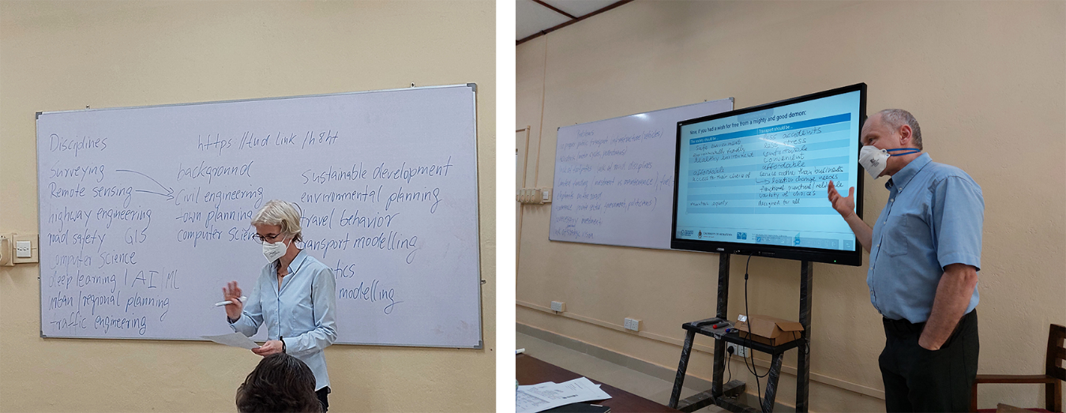
Prof. Regine Gerike and Prof. Udo Becker

The workshop's opening was an official welcome from UOM, followed by a welcome from the LBS2ITS organization team and an interactive introduction round of the participants. The first lecture, "Goals, visions, challenges, emerging trends in transport", discussed basic concepts in transportation planning, raised awareness for rebound effects and invited to discuss problems and opportunities in shaping future transportation systems. Based on this lecture, groups were formed, and issues for the group work were defined in the afternoon.
The workshop followed a similar structure for the next three days, Tuesday to Thursday: Group work was possible in the morning and afternoon, and lectures were given before and after lunch. This allowed external experts to join for selected topics and lectures and network during the lunch break. Results from the group work were presented on Friday, followed by a short feedback round and a farewell lunch. Each day, there were tea breaks in the morning and afternoon and a delicious lunch. Together with the social event on Friday, these breaks provided great opportunities for follow-up discussions.
The lectures first served to present research results and current developments in transportation planning from the European perspective and second to exchange perspectives. For each of the six lectures, one topic was chosen beforehand with the Sri Lankan partners in the preparatory video conferences. The topics ranged from strategic sustainable urban mobility plans (SUMPs) and functional street network classification to design principles for safe, efficient and liveable streets. Monitoring and evaluation, as well as externalities, were also covered. Throughout the lectures, there were lively discussions on challenges, opportunities and the current situation in Europe and Sri Lanka.
Three topics were chosen for the group work:
· 15-minute-city: The example of Paris inspired this group with the ambition to provide access to relevant destinations within 15 minutes of walking or cycling (see, e.g. https://www.15minutecity.com/). The group developed an interdisciplinary PBL-concept for training competencies in GIS, urban and transportation planning, and stakeholder interviews.
· Next-generation public transport in Colombo: The second group developed a concept for promoting public transport and stopping the current trend of decreasing public transport ridership. The concept was based on transit-oriented development principles in pre-defined corridors that should ideally be served by rail-based public transport or alternatively by bus services. Improvements for the bus fleet were suggested and solutions to enable the shift to more attractive vehicles and services in public transport.
· Street design standards: The third group worked on design principles for safe and liveable streets in Sri Lanka. Main problems and trends were identified in the first step, followed by the proposition of solutions and the suggestion of design standards.
It was a great week, and we thank our Sri Lankan partners for their hospitality and for providing a welcoming atmosphere inviting discussions and supporting a mutual understanding between the different disciplines and between Sri Lankan and European perspectives.
Regine Gerike on behalf of the TU Dresden team

